H.T No
Regulations:
A18

Sreenidhi Institute of Science and Technology
(An Autonomous Institution)
Code No:7F606 Date: 28-Aug-2021 (FN)

B.Tech III-Year II- Semester External Examination, Aug/Sept - 2021 (Regular)
AUTOMATA THEORY AND COMPILER DESIGN (CSE and IT)

Time: 3 Hours Max.Marks:70

Note: a) No additional answer sheets will be provided.
b) All sub-parts of a question must be answered at one place only, otherwise it will not be valued.
c) Missing data can be assumed suitably.

ANSWER ANY 5 OUT OF 8 QUESTIONS. EACH QUESTION CARRIES 14 MARKS.

Bloom's Cognitive Levels of Learning (BCLL)

Remember | L1 | Apply | L3 | Evaluate | L5
Understand | L2 | Analyze | L4 | Create | L6

 |  |  | BCLL | CO(s) | Marks
1. | a) | Construct the DFA for the following NFA  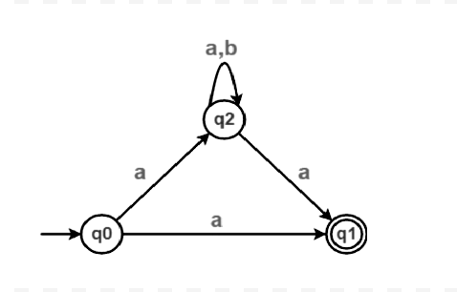 | L3 | CO1 | [7M]
 | b) | Design a finite automaton accepting language over an alphabet {a, b, c} with set of strings consisting of zero or more a’s followed by zero or more  b’s followed by zero or more c’s | L3 | CO1 | [7M]
2. | a) | Transform the following finite automata to regular expression.  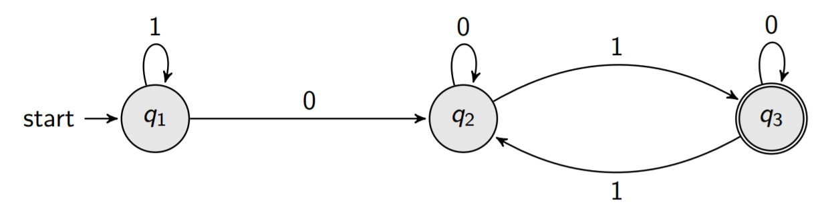 | L6 | CO2 | [7M]
 | b) | Define and solve the following  i) Left Most Derivation  ii) Right Most Derivation  iii) Construct LMD and RMD by assuming some string from the grammar  S → aSa | bSb | SS | a | b | L2 | CO2 | [7M]
3. | a) | Design the Turing machine of concatenation of two strings. | L3 | CO3 | [7M]
 | b) | Discuss the model of Push Down Automata and its acceptance of string by null store. | L2 | CO3 | [7M]
4. | a) | Illustrate each phase of compilation process with suitable example. | L2 | CO4 | [7M]
 | b) | What is meant by left recursion in CFG and check the following grammar is left recursive or not if it is, remove it.  E → E+T | T  T → T*F | F  F → (E) | id | L4 | CO4 | [7M]
5. | a) | Construct canonical collection of LR (0) items for the following grammar  E → E+T | T  T → T*F | F  F → (E) | id | L3 | CO5 | [7M]
 | b) | Design LALR(1) parsing table for the following grammar  S → CC  C → cD | d | L4 | CO5 | [7M]
6. | a) | Elaborate on principle sources of optimization. | L2 | CO6 | [7M]
 | b) | Compare Inherited and Synthesized attributes. | L4 | CO6 | [7M]
7. | a) | Compare non-deterministic and deterministic finite automations with suitable examples. | L4 | CO1 | [5M]
 | b) | State and prove Arden’s theorem. | L2 | CO2 | [5M]
 | c) | Classify the kinds of languages and their acceptors. | L4 | CO3 | [4M]
8. | a) | Discuss the functionality of LEX. | L4 | CO4 | [5M]
 | b) | Discuss the functionality of Shift Reduced Parser. | L4 | CO5 | [5M]
 | c) | Discuss the applications of DAG. | L4 | CO6 | [4M]

-- 00 -- 00 –

